# Understanding Bollinger Bands - Question Review

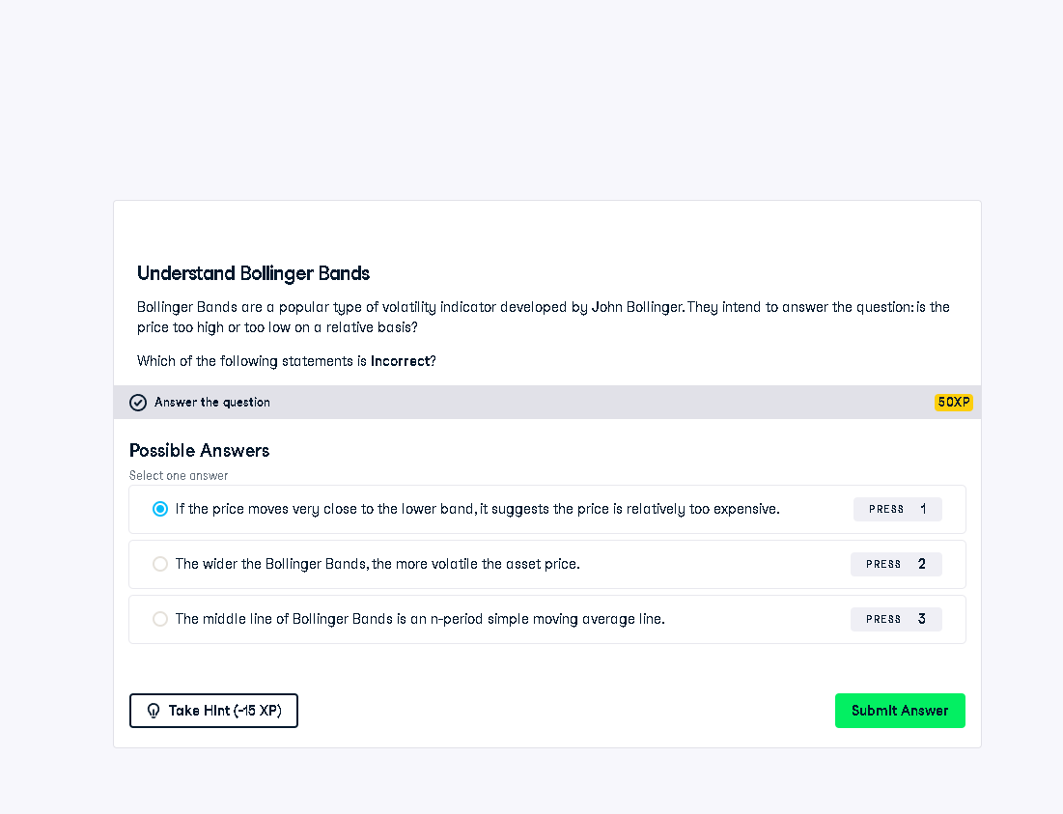

## Full Answer

❌ Incorrect Statement Selected:  
"If the price moves very close to the lower band, it suggests the price is relatively too expensive."  
  
✅ Correct Explanation:  
This statement is incorrect. When price approaches the lower Bollinger Band, it is generally seen as potentially undervalued—not too expensive. Bollinger Bands use volatility to determine relative high and low prices. The lower band can suggest potential buying opportunities, not overpricing.  
  
✅ Correct Statements:  
- The wider the Bollinger Bands, the more volatile the asset price.  
- The middle line of Bollinger Bands is a simple moving average (typically 20-period).

## Simple Explanation (50 Words)

Bollinger Bands help identify when prices are relatively high or low. If the price touches the lower band, it might be undervalued—not overpriced. That’s why the selected statement is incorrect. Correct answers describe that band width shows volatility, and the middle line is a moving average.